Supplementary information, Gawel et al. RSOS 17051

Supplementary Section 1: Sites

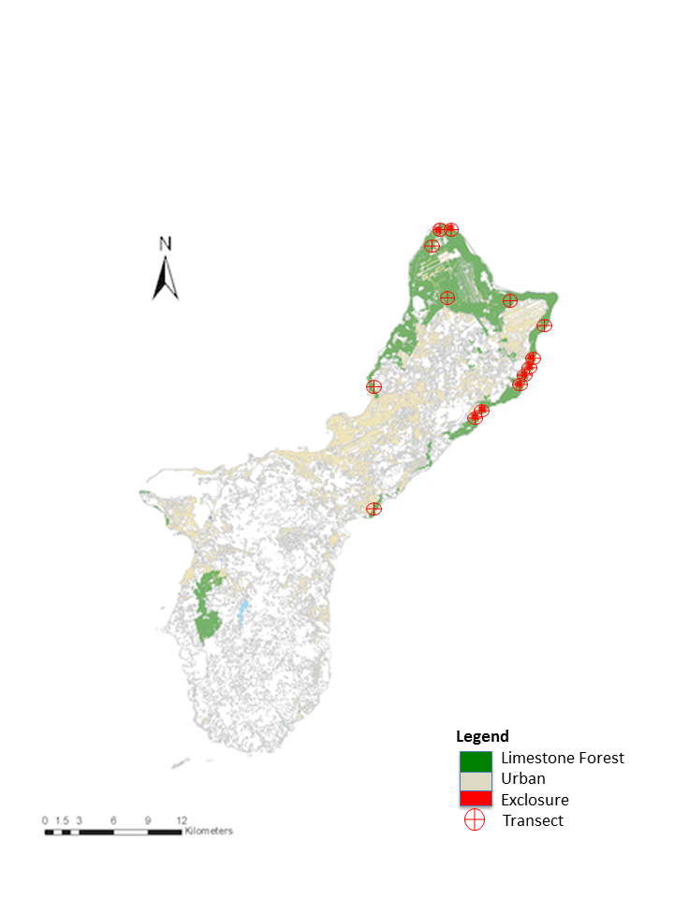

Supplementary Figure 1. Location of eight exclosures and 14 transects in Guam’s limestone karst forests.

Supplementary Section 2: Plots after removing highest deer density site.

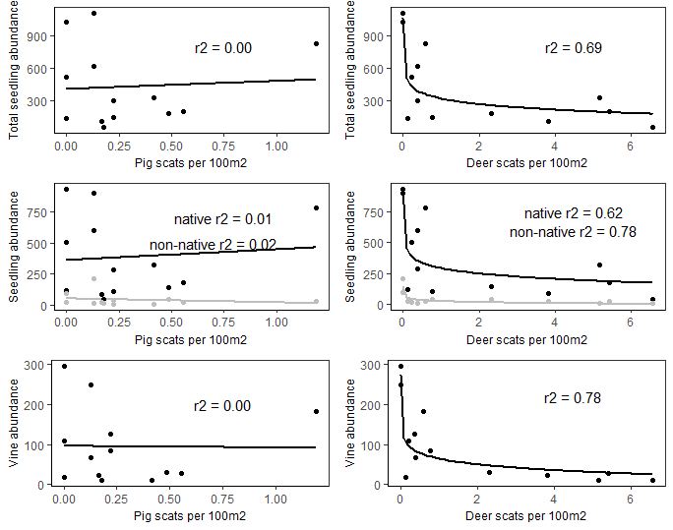

Supplementary Figure 2. Results from vegetation and scat surveys dropping “Tartop” site that had highest Deer scats per 100m2 value. Although scale of the x-axis is slightly smaller in the right-hand panel, trends and r2 values are almost identical to original results (see Figure 4 in manuscript).

Supplementary Section 3: comparisons of baseline characteristics of seedling plots chosen for fenced and ungulate treatments.

Supplementary Table 1: Comparison of paired plots at each site, using number of adult trees, average diameter at breast height (dbh), canopy cover, and average adult tree height.

|  |  |  |  |  |  |  |  |  |
| --- | --- | --- | --- | --- | --- | --- | --- | --- |
|  | Fenced | | | | Unfenced | | | |
| Site | # Adult trees | Avg dbh (cm) | Canopy cover | Avg height (m) | # Adult trees | Avg dbh (cm) | Canopy cover | Avg height (m) |
| Ritidian Grid | 6 | 14.67 | 0.82 | 9.17 | 5 | 16.2 | 0.84 | 8.3 |
| Ritidian Gate | 7 | 14.57 | 0.9 | 8.71 | 5 | 11.2 | 0.85 | 7.6 |
| Anao North | 6 | 10 | 0.84 | 10.6 | 8 | 19 | 0.84 | 11.06 |
| Anao South | 7 | 12 | 0.73 | 9.43 | 11 | 6.45 | 0.79 | 9.43 |
| North Blas | 13 | 8.23 | 0.85 | 7.62 | 6 | 4.75 | 0.82 | 7.75 |
| South Blas | 8 | 6.13 | 0.76 | 6.88 | 6 | 6.67 | 0.74 | 7.67 |
| Racetrack | 14 | 4.93 | 0.9 | 6.21 | 10 | 4.93 | 0.9 | 6.65 |
| Racetrack Fragment | 12 | 4 | 0.88 | 7.46 | 9 | 4 | 0.89 | 6.67 |

Supplementary Table 2: We used paired t-tests in R to assess if # of adult trees and proportion canopy cover differed significantly between treatments. We determined that these parameters do not differ significantly between seedling plots at each site.

|  |  |  |  |  |  |
| --- | --- | --- | --- | --- | --- |
| Parameter | t | df | p-value | 95% CI | Mean of differences |
| # adult trees | 1.34 | 7 | 0.22 | -1.23 – 4.48 | 1.63 |
| Canopy cover | 0.11 | 7 | 0.92 | -0.03 – 0.03 | 0.00 |

Supplementary Table 3: Since the number of adult trees was different between each site, instead of using t-tests to determine if DBH and heights were significantly different, we used an lsmeans approach. Results are presented below, and strongly suggest that DBH and height of adult trees did not differ between treatments plots. Therefore, our results in the manuscript of differences based on treatment effects for each species of planted seedlings do not appear to be due to inherent characteristics of the sites.

|  |  |  |  |  |  |  |
| --- | --- | --- | --- | --- | --- | --- |
| Paremeter | Treatment | Lsmean | SE | df | Contrast t-ratio | Contrast p-value |
| Height | Fenced | 8.14 | 0.36 | 119 | 0.19 | 0.85 |
| Height | Unfenced | 8.04 | 0.39 | 119 |
| DBH | Fenced | 9.31 | 0.57 | 119 | 0.28 | 0.78 |
| DBH | Unfenced | 9.08 | 0.61 | 119 |

A.

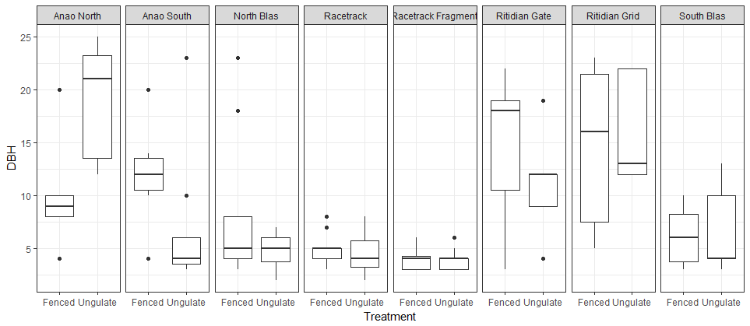

B.

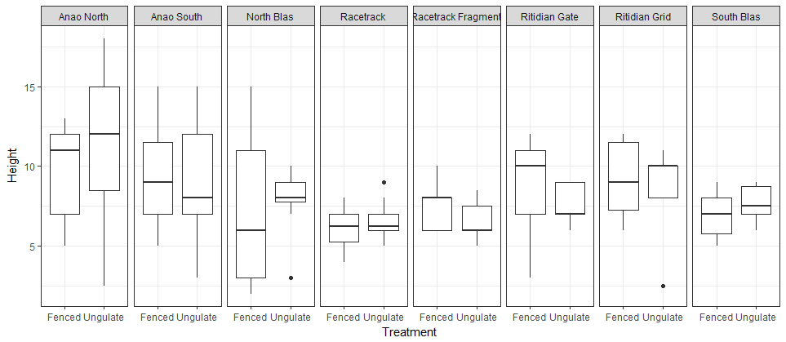

Supplementary Figure 3. Boxplot shows that while that differences in DBH and height in adult trees in paired plots are not biased in one direction, even though some differences occur.

In addition, we included qualitative descriptions of the sites in the table below.

|  |  |  |  |
| --- | --- | --- | --- |
| Site |  | Fenced | Unfenced/Ungulate |
| Ritidian Grid | Substrate | Solid karst formations in southeast corner of plot, large amounts of *Ochrosia oppositifolia* leaf litter | Mostly flat with scattered limestone rocks 10-20 cm in diameter, mixed leaf litter |
|  | Slope | 0 | 0 |
|  | Species of adult trees | *Ochrosia oppositifolia, Aglaia mariannensis, Meiogyne cylindrocarpa* | *Ochrosia oppositifolia, Psychotria mariana, Cycas micronesica* |
| Ritidian Gate | Substrate | Mostly 5-10cm-diameter rocks with few large, 50-cm-high boulders, <20% exposed red soil | Few large, 50-cm-high boulders, <20% exposed red soil, mostly 5-10cm-diameter rocks |
|  | Slope | 0 | slight downward slope (<5 degrees) towards NW |
|  | Species of adult trees | *Ochrosia oppositifolia, Algaia mariannensis, Triphasia trifolia* | *Aglaia mariannensis, Mammea odorata, Ochrosia oppositifolia* |
| Anao North | Substrate | very rocky, no soil visible, rocks from 5 - 50-cm in diameter | very rocky, no soil visible, rocks from 5 - 50-cm in diameter |
|  | Slope | 0 | 0 |
|  | Species of adult trees | *Ochrosia oppositifolia, Meiogyne cylindrocarpa* (*Macaranga thompsonii,* out of plot, but canopy overhanging plot) | *Ochrosia oppositifolia, Cycas micronesica, Macaranga thompsonii* |
| Anao South | Substrate | 60% of ground cover is large rocks >20cm in diameter, some (~20% substrate) exposed red dirt | very rocky, loose rocks 10-50cm in diameter, small amounts (~10-15%) of exposed red dirt |
|  | Slope | flat | slight downward slope (<5 degrees) towards east |
|  | # adult trees | 7 | 11 |
|  | Species of adult trees | *Mammea odorata, Aglaia mariannensis, Meiogyne cylindrocarpa, Ochrosia oppositifolia* | *Mammea odorata, Ochrosia oppositifolia, Cynometra ramiflora, Meiogyne cylindrocarpa* |
| North Blas | Substrate | very rocky, no soil visible, rocks approx. 50cm in diameter | very rocky, no soil visible, rocks approx. 50cm in diameter |
|  | Slope | slight slope (<5 degs) downward towards NE, tower karst intermittent on all sides | in slight depression between towers of karst on north and south sides |
|  | Species of adult trees | *Aglaia mariannensis, Cynometra ramiflora, Morinda citrifolia, Macaranga thompsonii, Syzigium thompsonii* | *Aglaia mariannensis, Meiogyne cylindrocarpa, Mammea odorata* |
| South Blas | Substrate | very rugged; large, solid rocks on south side of plot, no soil showing | rugged, no soil showing |
|  | Slope | 0 | 0 |
|  | Species of adult trees | *Meiogyne cylindrocarpa, Ochrosia mariannensis* | *Meiogyne cylindrocarpa, Ochrosia mariannensis, Macaranga thompsonii* |
| Racetrack | Substrate | moderate karst, scattered boulders 0.5-m in diameter | moderate karst, scattered boulders and rocks 0.2 to 0.5-m in diameter |
|  | Slope | 0 | 0 |
|  | Species of adult trees | *Eugenia reinwardtiana* | *Eugenia reinwardtiana, Meiogyne cylindrocarpa* |
| Racetrack Fragment | Substrate | very rocky, high amount of *Eugenia* leaf litter | very rocky, high amount of *Eugenia* leaf litter |
|  | Slope | 0 | 0 |
|  | Species of adult trees | *Eugenia reinwardtiana, Aglaia mariannensis* | *Eugenia reinwardtiana* |

Supplementary Section 4: Model selection for linear models of vegetation characteristics explained by pig and deer scat abundance.

*Total seedlings*

K AICc Delta_AICc AICcWt Cum.Wt LL

Deer 3 206.06 0.00 0.81 0.81 -98.83

Deer + Pigs 4 209.55 3.49 0.14 0.96 -98.56

Pigs 3 211.90 5.84 0.04 1.00 -101.75

*Native seedlings*

K AICc Delta_AICc AICcWt Cum.Wt LL

Deer 3 202.53 0.00 0.81 0.81 -97.07

Deer + Pigs 4 205.93 3.40 0.15 0.95 -96.74

Pigs 3 208.26 5.73 0.05 1.00 -99.93

*Exotic seedlings*

Model selection based on AICc:

K AICc Delta_AICc AICcWt Cum.Wt LL

Deer 3 156.83 0.00 0.72 0.72 -74.22

Pigs 3 159.64 2.81 0.18 0.90 -75.62

Deer + Pigs 4 160.80 3.97 0.10 1.00 -74.18

*Vines*

K AICc Delta_AICc AICcWt Cum.Wt LL

Deer 3 167.50 0.00 0.85 0.85 -79.55

Deer + Pigs 4 171.35 3.85 0.12 0.98 -79.45

Pigs 3 174.59 7.09 0.02 1.00 -83.10

Deer scat abundance was consistently part of the best fit model to explain seedling abundances and vine abundance, while the models with pig scat abundance and both pig and deer scat abundance were not.